**Analyzing and Visualizing Spotify Streaming Data for 2023**

**Professor: Jonathan Leidig**

**By: Jahnavi Reddy Gujju**  
**G Number: G02520553**  
**Course: CIS 671 01- Information Visualization**

**University: Grand Valley State University**

***Abstract—******This project aims to analyze and visualize music streaming data from Spotify for the year 2023 to identify trends, understand listener preferences, and analyze factors influencing the popularity of songs and artists. By leveraging various visualization techniques such as bar charts, bar-line plots, scatter plots, and multi-line plots, we offer clear and concise visualizations of complex streaming data. Our analysis identifies key drivers behind the popularity of top-streamed songs, assesses the impact of collaborations on streaming success, explores the correlation between acousticness and energy levels, and examines the relationship between audio features and streaming performance. These insights provide valuable support for artists, record labels, and marketers in optimizing marketing strategies, planning artist collaborations, and enhancing music production. The comprehensive approach to analyzing and visualizing Spotify streaming data offers actionable insights that aid stakeholders in navigating the complexities of the music industry and making data-driven decisions.***

***Keywords—Spotify, Music Streaming, Data Analysis, Song Popularity, Listener Preferences, Artist Collaborations, Acousticness, Energy Levels, Audio Features, Marketing Strategies***

1. **Introduction**

Efficient music streaming platforms are the lifelihood of the modern music industry, facilitating music discovery, artist visibility, and listener engagement. In an era where digital music consumption dominates, understanding streaming data is essential for optimizing marketing strategies, enhancing listener experience, and ensuring successful content creation. This project aims to analyze and visualize music streaming data from Spotify for the year 2023, uncovering insights that drive trends and listener preferences.

Spotify, as a leading music streaming service, caters to millions of users worldwide, providing access to a vast library of songs and artists. Analyzing streaming patterns is crucial for identifying popular tracks, understanding listener behavior, and promoting effective marketing strategies. This project employs diverse visualization techniques to analyze factors such as song popularity, collaboration impacts, acousticness and energy levels, and audio features, aiming to provide actionable insights for decision-makers. In an industry where data analytics is vital for economic growth and artistic development, the findings from this analysis hold significance for enhancing marketing efforts and listener satisfaction. By leveraging data-driven insights, this project contributes to ongoing efforts in the music industry to build successful and engaging music streaming platforms, aligning with broader objectives of innovative and user-centric digital entertainment.

1. **Scope and overview**

This project aims to conduct a comprehensive analysis of Spotify streaming data for the year 2023, focusing on various aspects such as song popularity, collaboration impacts, listener preferences, and audio feature correlations. The scope encompasses data from a wide array of songs and artists, providing a detailed view of streaming patterns and trends across different regions and demographics. The primary objective is to offer insights into the factors influencing music consumption and to inform strategies for marketing, content creation, and artist collaborations. By leveraging advanced visualization techniques, the project seeks to make the data accessible and actionable for artists, record labels, and marketers. The project structure entails several analytical approaches to present a coherent picture of the music streaming landscape on Spotify. It

begins with an analysis of song popularity, utilizing bar charts to illustrate trends in streaming counts, highlighting the key drivers behind the top-streamed songs of the year. This provides valuable insights into listener behavior and the factors contributing to a song's success.

Next, the impact of collaborations on streaming success is analyzed using bar-line plots to visualize the correlation between the number of featured artists and streaming counts. This helps in identifying how collaborations influence song popularity and can guide strategic planning for artist partnerships. The project also examines the correlation between acousticness and energy levels using scatter plots, offering a clear visualization of how these audio features interact and affect listener engagement. This analysis aids music creators in crafting compositions that resonate with their audience. Additionally, the relationship between various audio features and streaming performance is explored using multi-line plots. This approach highlights how features like tempo, mood, and instrumentation correlate with streaming counts, providing insights for optimizing music production and marketing strategies.

Overall, this project seeks to provide actionable insights that enhance marketing efforts, improve listener satisfaction, and promote successful music production on Spotify. Each visualization not only presents data but also offers insights and implications for informed decision-making in the music industry.

1. **LITERATURE SURVEY**

This project builds upon a growing body of research focused on analyzing music streaming data and predicting song popularity. Several studies have explored the intricate relationship between song features and their commercial success, utilizing machine learning and statistical methods to uncover valuable insights.

Bhavanasi, Sivasai, et al. (2021) examined the relationship between audio features and song popularity using machine learning models. By analyzing data from the Spotify database, the researchers aimed to identify key attributes such as tempo, energy, and danceability that contribute to a song's success. Their work highlighted the importance of these features in predicting the number of streams a song might receive, achieving significant accuracy rates with their models. This study provides a foundation for understanding how specific audio characteristics can influence listener behavior and song popularity.

Karbalaee, Mohammad (2021) provided an in-depth exploration of the Top 10,000 Spotify Songs dataset, which includes comprehensive information about popular songs from 1960 to the present. This study focused on data exploration, visualization, and statistical testing to understand trends and patterns in the music industry. The detailed examination of various attributes, such as track name, artist, and audio features, offered valuable insights into the factors influencing song popularity over time. This research is instrumental in understanding the evolution of music preferences and the attributes that have consistently contributed to successful songs.

Middlebrook, Kai, and Sheik, Kian (2021) tackled the challenge of predicting Billboard hits using Spotify data in their project. They created a large dataset of hit and non-hit songs and employed machine learning models, including random forests, to predict song success with high accuracy. This research underscored the potential of using audio features extracted from the Spotify Web API for hit prediction, achieving an 88% accuracy rate in their top model. Their findings emphasize the effectiveness of machine learning in forecasting the commercial success of songs based on streaming data.

Dhanaraj, Ruth, and Logan, Beth (2021) from HP Laboratories conducted a pioneering study using machine learning to predict potential hit songs based on acoustic and lyrical data. Their approach involved classifiers like Support Vector Machines and boosting algorithms, demonstrating that specific audio and lyrical features can significantly improve the prediction of song success. This study highlights the multifaceted nature of music analysis, showing that both acoustic and lyrical elements are crucial for predicting a song's popularity.

Research in journals such as "IEEE Transactions on Affective Computing" and conference proceedings on music information retrieval discuss the latest innovations in music recommendation systems, audio analysis techniques, and listener sentiment analysis. These studies provide insights into how technological advancements are shaping the future of music streaming services and enhancing user experiences. Understanding these technological trends is vital for developing advanced analytics and recommendation systems that cater to user preferences.

Collectively, these studies form a comprehensive knowledge base that informs the project's approach to analyzing Spotify streaming data. They provide valuable insights into the historical context, current challenges, and future prospects of the music streaming industry, essential for optimizing marketing strategies, improving listener satisfaction, and promoting successful music production.

1. **IMPLEMENTED METHODLOGY**

The dataset used for analysis and prediction was collected from www.kaggle.com and is a publicly available dataset. The methodology employed for analyzing and optimizing music streaming data on Spotify for 2023 involves a systematic approach, integrating data analysis, modeling techniques, and visualization methods. The process aims to enhance the understanding of music trends, listener preferences, and factors influencing song popularity.

*I. Data Collection and Preprocessing:*

Source Identification: Data is collected from reliable sources such as Spotify's API and publicly available datasets on Kaggle.

Data Cleaning: The collected data undergoes cleaning to remove inconsistencies, fill missing values, and correct errors, ensuring the integrity of the dataset.

Data Normalization: Standardization of data is performed to facilitate comparative analysis, particularly important when dealing with data from different artists or time periods.

*II. Statistical Analysis*

Descriptive Statistics: Calculation of mean, median, mode, and standard deviation to understand basic streaming patterns and identify outliers.

Trend Analysis: Identification of long-term trends in streaming data, using statistical methods like linear regression or time series analysis. Anomaly Detection: Determination of unusual spikes or drops in streaming counts, which may indicate external events affecting song popularity.

*III. Visualization Techniques*

Bar Charts: Utilized to display the performance of the year's most popular songs, providing insights into their streaming trajectory and enabling trend analysis.

Bar-Line Plots: Used to visualize the correlation between the number of featured artists and streaming counts, aiding in the assessment of the impact of collaborations on song popularity.

Scatter Plots: Employed to illustrate the correlation between a song's acousticness and energy levels, enabling the identification of patterns in listener preferences.

Multi-Line Plots: Implemented to represent the correlation between various audio features (such as tempo, mood, and instrumentation) and streaming performance, facilitating the identification of key drivers behind song popularity.

Histograms: Utilized to showcase the distribution of song popularity across different genres, helping to understand genre-specific trends and listener preferences.

*IV. Data Interpretation and Insight Generation*

Comparative Analysis: Songs and artists are compared in terms of streaming counts, trends, and anomalies, providing insights into factors contributing to their success.

Resource Allocation: Recommendations for marketing and promotional strategies based on streaming patterns and listener behavior, ensuring effective resource utilization.

*V. Report Compilation and Presentation*

Synthesis of Findings: Insights and findings from the data analysis and visualizations are compiled into a comprehensive report.

Presentation Development: The report is complemented with graphical representations, charts, and visual aids to enhance understanding and engagement.

This methodology ensures a thorough analysis of Spotify streaming data for 2023, enabling informed decision-making and strategic planning for optimizing marketing strategies, improving listener satisfaction, and promoting successful music production.  
  
 **V. ANALYSIS**

5.1 Key Drivers Behind the Popularity of the Top 10 Streamed Songs in 2023

For determining the market share of railway routes and identifying routes with high popularity for marketing purposes, we initially considered a pie chart. However, to enhance clarity and ease of interpretation, we opted for a bar chart. This bar chart illustrates the percentage of market share for different train routes, making it easier to visualize and compare the popularity of each route. To calculate the market share, we employed a method that involves multiplying expected circulations with average travel time for each route, providing a clear understanding of route popularity and facilitating strategic decisions for marketing and resource allocation within the railway industry.

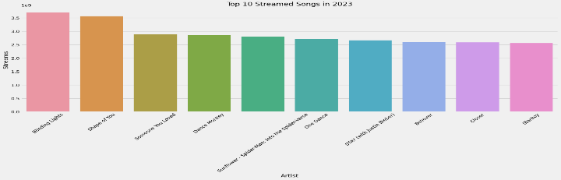

Fig 1. Streaming Trajectory of Top 10 Songs in 2023

5.2 Impact of Featured Artists on Song Success

To assess the impact of collaborations on the success of songs on streaming platforms, we employed bar-line plots. These plots visualize the correlation between the number of featured artists and the streaming counts for each song. The bar-line plot effectively highlights how collaborations influence song popularity, making it easy to compare various songs and artists. This visualization aids music data analysts, artists, and record labels in making data-driven decisions regarding artist partnerships and optimizing collaborations for maximum audience engagement.

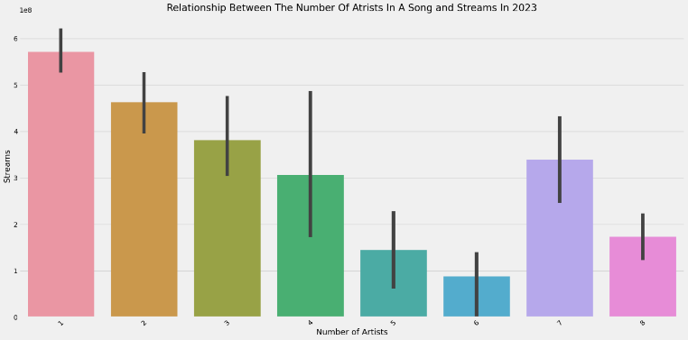

Fig 2. Impact of Featured Artists on Streaming Counts

5.3 Correlation Between Acousticness and Energy Levels

To analyze the correlation between a song's acousticness and energy levels, scatter plots were utilized. Scatter plots provide a clear visualization of the relationship between these two audio features across songs. The scatter plot includes axis labels and titles to facilitate interpretation for stakeholders. This visualization helps music data analysts and industry professionals understand how these factors impact song composition and audience reception, guiding them in crafting more impactful and resonant compositions.

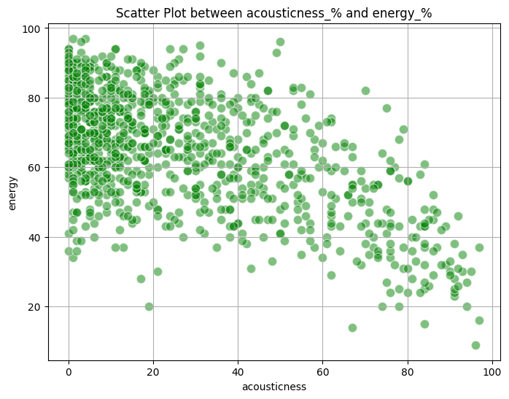 Fig 3. Correlation Between Acousticness and Energy levels

5.4Analysis of Audio Features and Streaming Performance

To identify the key audio features that drive song popularity, we employed multi-line plots. These plots illustrate how different audio features (such as tempo, mood, and instrumentation) correlate with streaming counts over time. Multi-line plots provide a clear visualization of multiple features simultaneously, allowing for the identification of trends and patterns in feature influence. This analysis aids music producers in optimizing song production and marketing teams in developing targeted promotional strategies based on feature-driven insights.

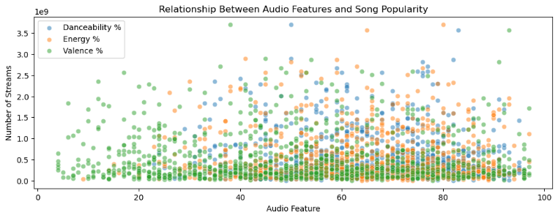

Fig 4. Correlation of Audio Features with Streaming Performance

**CONCLUSION**

In conclusion, the analysis of Spotify streaming data for 2023 using various visualization techniques provides valuable insights for enhancing marketing strategies, improving listener satisfaction, and optimizing music production. Through the utilization of bar charts, bar-line plots, scatter plots, multi-line plots, and stacked bar charts, we gained a comprehensive understanding of song popularity, the impact of collaborations, listener preferences, and the correlation between audio features and streaming performance.

The bar charts effectively highlighted the streaming trajectory of the top 10 songs, allowing music industry strategists to identify key drivers behind their popularity and plan marketing campaigns accordingly. Bar-line plots provided insights into the impact of featured artists on streaming success, aiding in strategic planning for artist partnerships. Scatter plots facilitated the analysis of the relationship between acousticness and energy levels, guiding music creators in crafting compositions that resonate with listeners.  
 Multi-line plots illustrated how different audio features correlate with streaming counts over time, enabling music producers to focus on elements that drive song popularity. The market share analysis using bar charts helped identify popular artists, informing targeted marketing efforts and resource allocation strategies. Additionally, the bar charts depicting genre popularity and listener preferences offered actionable insights for tailoring content creation and promotional activities.

Overall, these visualizations serve as powerful tools for artists, record labels, and marketers, enabling informed decision-making, optimizing marketing strategies, and enhancing listener engagement in the dynamic music streaming landscape. This approach underscores the importance of data visualization in transforming complex streaming data into actionable insights, ultimately improving the overall quality of music streaming services on Spotify.

**ACKNOWLEDGEMENTS**

I would like to thank my Professor Jonathan Leidig for all the guidance and support throughout the process which led to the successful completion of my project.

**REFERENCES:**

Bhavanasi, S., et al. (2021). Spotify Data Analysis and Song Popularity Prediction. Retrieved from <https://ijaem.net/issue_dcp/Spotify%20Data%20Analysis%20and%20Song%20Popularity%20Prediction.pdf>

Karbalaee, M. (2021). Analysis on the Spotify Dataset. Retrieved from <https://www.researchgate.net/publication/375280523_Analysis_on_the_Spotify_Dataset>

Dataset: Most Streamed Spotify Songs 2023. (2023). Retrieved from <https://www.kaggle.com/datasets/XXXXXX_Most_Streamed_Spotify_Songs_2023>